HW_template_Rmarkdown

Pedram Jahangiry

# Problems

## Question 1

### (i)

This is my answer to section (i)

### (ii)

This is my answer to section (ii)

# Computer Exercises

## C1 Use the data in wage1 for this exercise.

### (i)

This is my answer to section (i)

# Including r output within some text

for example I calculated the average number of cars as:

avg_speed <- mean(cars$speed)  
avg_speed

## [1] 15.4

from the R output above, we see that the average speed is equal to 15.4.

Or you could directly do some in-line calculations. Here is the average speed: 15.4.

We can also insert plots from R in Rmarkdown:

hist(wage2$wage, col="red")

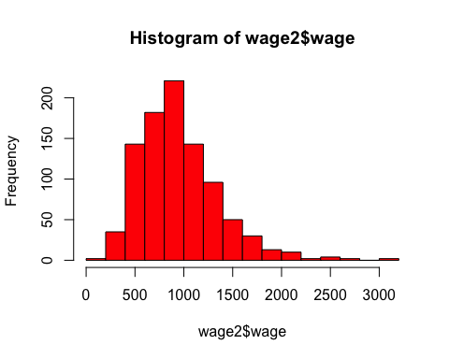

How to write mathematical formulas in **Rmarkdown**:

1. Writing in-line formulas using one dollar sign: $y=β_{0}+β_{1}x_{1}+...+β_{k}x_{k}+u$
2. Writing centered and stand alone formulas using 2 dollar signs:

$$y=β_{0}+β_{1}x_{1}+...+β_{k}x_{k}+u$$

$$P(X|Y)$$

$log(salary)$

$P(X≤6)$

$f(x)=3x^{2}−2x^{3}$ then $0≤x≤1$